DevOps

Assignment 2017

Team Polo

Andrea Cole L00115856

Cathal Keany L00115066

Conor McGinty- L00117391

Liam Whorriskey- L00113360

Eimear Mc Cann- L00105764

Maria gibson- L00105748

B.Sc. in Computing

Enterprise Applications

Assignment 2017

Health insurance On-line system to enter

Customer’s details

By

Team Polo

Andrea Cole L00115856

Cathal Keany L00115066

Conor McGinty- L00117391

Liam Whorriskey- L00113360

Eimear Mc Cann- L00105764

Maria gibson- L00105748

Requested By

Lecture: Ruth Lennon

**Introduction**

**Project Overview**

This project has been developed by Group2 Team Polo for an Assignment in DevOps at Letterkenny Institute of Technology.

The system has been developed for a health insurance company, enabling customers to use this on-line system to enter their details. This system is designed to calculate the risk and produce a cost of insurance for client. This is a secure system that’s takes into account personal details and private health information and foreign travel. The administrator has full access to edit details, however once client has entered details no further access is necessary.

Development has occurred over a number of weeks individually at home and through sessions together in study rooms on a weekly basis these were scrum style Stand-up meetings to critic progress. Working as a team the specification was framed. As the project progress Jira was used to progress and track work load. Github was used to push documentation and upload code.

Throughout this document there shall be an insight into the system, employed development methodologies and overview of the team co-operation and implementation.

**Scrums**

First Scrum meeting Use case and State diagrams for health Insurance project were drawn.

All team members were present and participated input. Results are as follows: 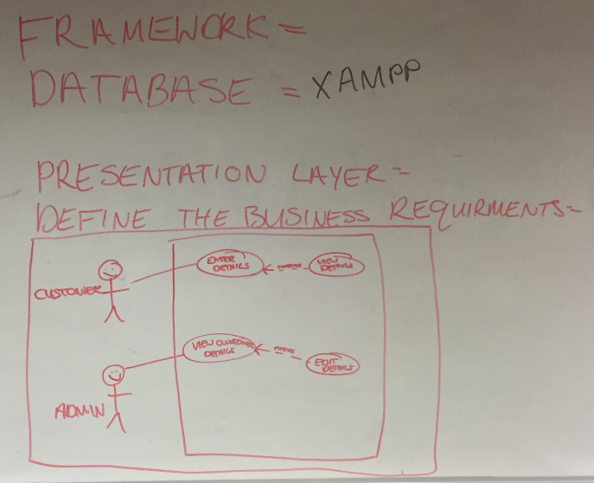

**Fig 1 Use Case Diagram Customer**

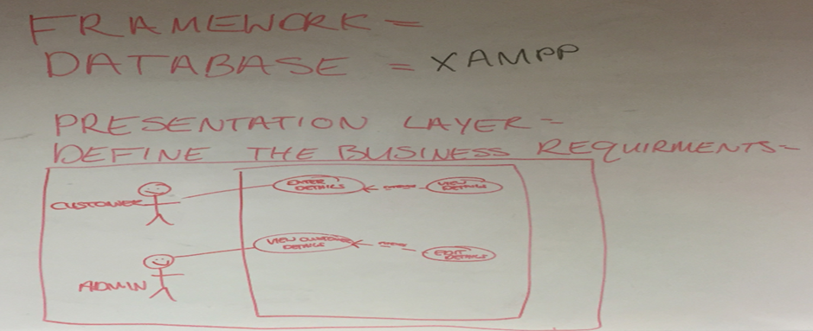 **Fig 2. Use Case Diagram Administrator**

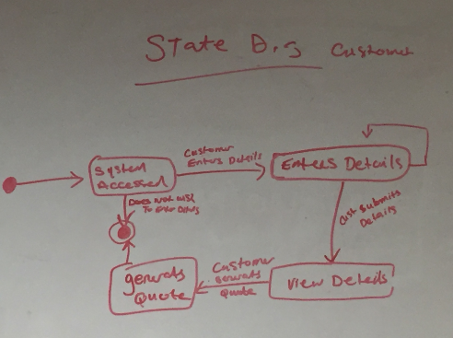

**Fig 3. State Diagram Customer**

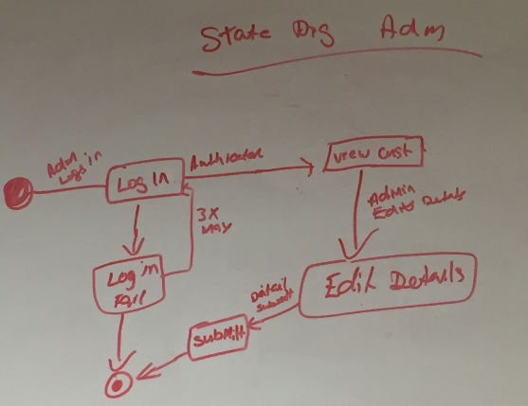 **Fig 4. State Diagram Administrator**

**Summary**

Research was conducted into application design, testing, database development and web application. Results will highlight reason for chosen path in conducting this project. Java connection has now been requested for by Customer.

**Technical description of project**

* *Hardware requirements*

The software as this would have the Database and Administration Functionally installed on the Health Insurance Company’s IT infrastructure. The Customer Web application development.

* *Software*

*(To Do)*

* ERD/Class Diagram- (To Do)
* Tables- Please see appendix

**Methodology (SDLC)**

The team decided to implement a proto-type Development Life-Cycle. This was chosen to allow the team to branch off with a number of team members working on Web development, App frontend and Database creation.

**Application Design**

**Research into software of web application testing**

1. JWebUnit - Tests web applications. Can be associated with selenium
2. Selenium - Automation testing of functionality.
3. LoadRunner - Load testing. Tests web application with a heavy load.
4. Qtest – Web loading testing tool.
5. TestComplete – Automation testing.
6. Katalon – Is used alongside Selenium.

From researching the different software, in my opinion JWebUnit and Selenium are the most efficient for the project.

**Database Design**

Reasons for using an SQL database for Project

1. **High Speed**.

SQL queries can search and fetch high volumes of data from database in a quick and efficient manner.

1. **Easy to Manage**

Using standard SQL means it is easy to manage the database without the need for a lot of coding.

1. **Supports OOP**

SQL can support and communicate with object orientated programming which makes it flexible when using it in a database for applications.

1. **Compatibility**

SQL Database can be used with Bootstrap which is the open source front end framework selected for the online application.

An rds database has been created on AWS by Eimear on her aws account.

Hosting it on the cloud made it easier for both to work on the database.

Access connection to the database on SQL workbench paste the following - *devops.cyivwen45nzy.us-east-2.rds.amazonaws.com*

Into the host section when setting up a new connection.

Use port 3306.

The password is grouppolo

Security group has been configured so anyone can access the database which is convenient for the purpose of this project

Polo Insurance Instructions

Created an SQL database for Polo Insurance on an Amazon AWS server so it can be accessed by everyone. Two sample tables were created like discussed, Customer_table, which will include Name, address, phone etc, and a Quoate table, which will include if the customer is a smoker or travels outside Europe or US and so on. These tables will be updated as we move forward as a team. Please use the following Hostname on My SQL Workbench when connecting to the database. The Log in details are noted below to allow access to the database. Any issues with this database can be updated easily so don’t hesitate to contact me through our group email or in the next sprint. Some sample data was also entered to test the database.

**UserName:** Devops

**Password:** grouppolo

1. Download MySQL work bench (.NET and Visual c++ 2015 will have to be downloaded as prerequisites).
2. + to add a new hostname and enter the hostname stated below.
3. UserName and Password will have to be entered that is stated above.

**HostName:** devops.cyivwen45nzy.us-east-2.rds.amazonaws.com

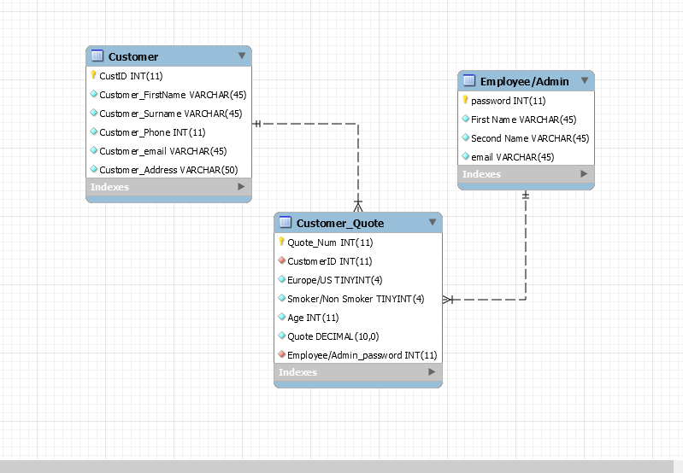

Fig 5. ERD Diagram- Revers engineered in database

**Web Development:** Liam Worskie, Maria Gibson. As Maria had no prior experience on Web Development Liam agreed to mentor Maria in web design through a series of meetings to discuss design and development.

Discussion on Layout of web design page:

|  |
| --- |
| Navigation  Header  Side Bar  Content  Quote  Footer |

**Fig 5. Web Page Design**

Prototype – Web Page Access on link192.com /http://link192.com/agents.php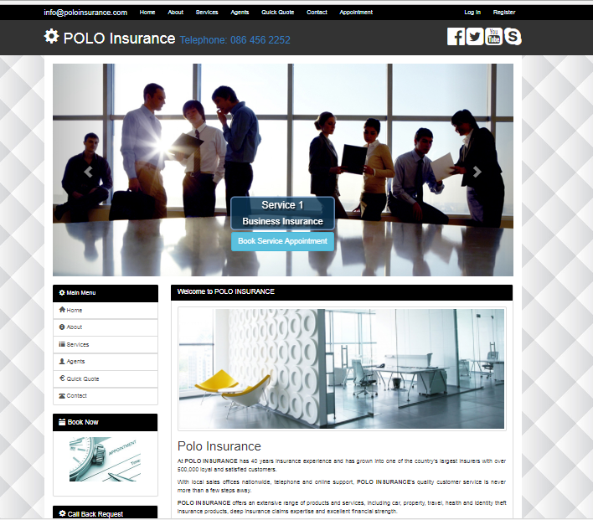

Fig 6 Home Web Page

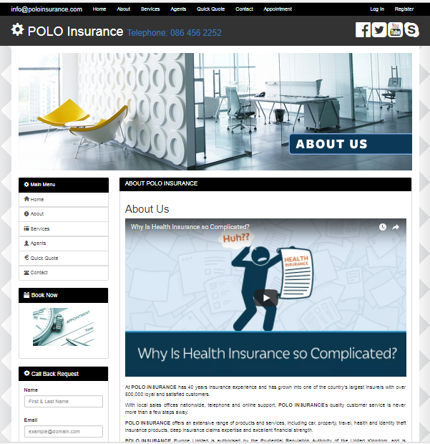

Fig 7. About Webpage

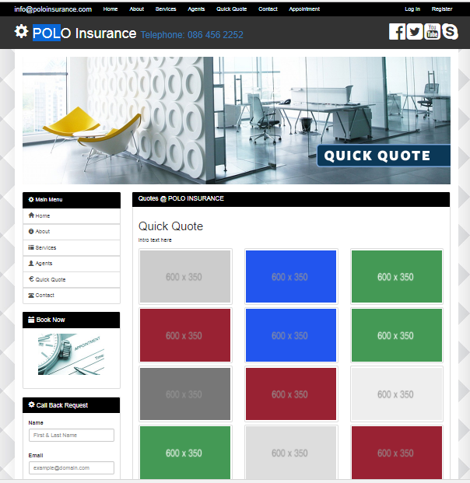

Fig 8. Quick Quote Webpage

**Appendices**

**Sample Tables in Database**

**Table 1.1**

**Customer Table**

|  |  |  |  |  |  |
| --- | --- | --- | --- | --- | --- |
| **ID** | **Name** | **Surname** | **Address** | **Email** | **Phone No.** |
| **Primary key** |  |  |  |  |  |
|  |  |  |  |  |  |

**Table 1.2**

**Quote Table**

|  |  |  |  |
| --- | --- | --- | --- |
| **Europe/US** | **Smoker/NonSmoker** | **Age** | **65+?** |
|  |  |  |  |